1. The staff in the HR department wants to hide some of the data in the EMPLOYEES table. They want a view called EMPLOYEES_VU based on the employee numbers, employee names, and department numbers from the EMPLOYEES table. They want the heading for the employee name to be EMPLOYEE.

2. Confirm that the view works. Display the contents of the EMPLOYEES_VU view.

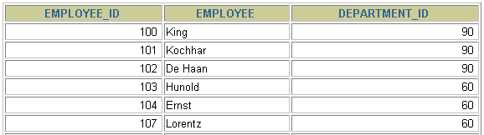

**…**

3. Using your EMPLOYEES_VU view, write a query for the HR department to display all employee names and department numbers.

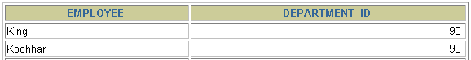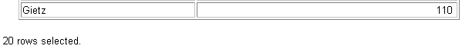

**…**

4. Department 50 needs access to its employee data. Create a view named DEPT50 that contains the employee numbers, employee last names, and department numbers for all employees in department 50. You have been asked to label the view columns  
 EMPNO, EMPLOYEE, and DEPTNO.

5. Display the structure and contents of the DEPT50 view.